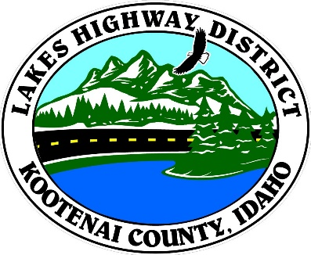

LAKES HIGHWAY DISTRICT
NOTICE OF SPECIAL MEETING

The Chairman of the Board of Commissioners of the Lakes Highway District has called a special meeting to be held on October 16, 2019 at the hour of 4:30 p.m. to be held at 11341 N. Ramsey Road, Hayden, Idaho 83835, for the purpose of:

- Call Meeting to Order
- Pledge of Allegiance
- Approve October 16, 2019 Special Meeting Agenda – Action Item
4. Approve October 7th Meeting Minutes – Actin Item
5. Public Comment - this section is reserved for citizens wishing to address the Board regarding a District related issue. Comments are limited to two (2) minutes per person. Idaho Law prohibits Board action on items brought under this section.

6. Old Business
a. AED Purchase – Action Item
b. Twenty Acre Wood Plat Review – Action Item

7. Current Business
a. Roberts Family Acres Plat Review – Action Item
b. Weir & Remington Road Geo Technical Agreement – Action Item
c. Set Public Hearing for Validation of Viewer Report Nos. 75 & 176 – Action Item
d. Winter Season PSA – Action Item
e. ITD Update – Hwy 95 Traffic Control – Action Item

8. Regular Scheduled Meeting on October 21, 2019 has been cancelled and all items deferred to the October 16, 2019 Special Meeting. Next regular scheduled Board Meeting is November 4, 2019.

9. Commissioner Comments

10. Adjourn
BOARD OF COMMISSIONERS
THE LAKES HIGHWAY DISTRICT

Rodney A. Twete, Chairman

Any person needing special accommodations to participate in the above noticed meeting should contact Lakes Highway District two (2) business days prior to the meeting at (208)772-7527.

Posted October 15, 2019 @ 1:15 p.m.

