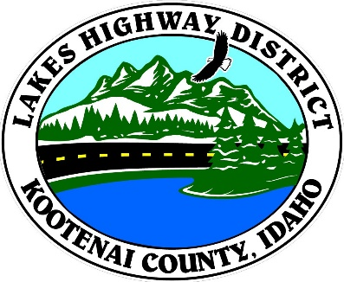

LAKES HIGHWAY DISTRICT
NOTICE OF SPECIAL MEETING

The Chairman of the Board of Commissioners of the Lakes Highway District has called a special meeting to be held on October 18, 2018 at the hour of 2:30 p.m. to be held at 11341 N. Ramsey Road, Hayden, Idaho 83835, for the purpose of:

1. Call Meeting to Order
2. Pledge of Allegiance
3. Approve October 18, 2018 Special Meeting Agenda
Regular Session
1. Bunco Road Soil Testing – Action Item
2. Consider Pressure Washer Purchase - Action Item
3. Surplus Truck T123 Transfer to City of Spirit Lake – Action Item
4.
Executive Session
- Idaho Code §74-206 (1) (a) – Hiring Public Employees – Action Item

BOARD OF COMMISSIONERS
THE LAKES HIGHWAY DISTRICT:

Rodney A. Twete, Chairman

Any person needing special accommodations to participate in the above noticed meeting should contact Lakes Highway District two (2) business days prior to the meeting at (208)772-7527.

Posted October 18, 2018 @ 1:00 p.m.

