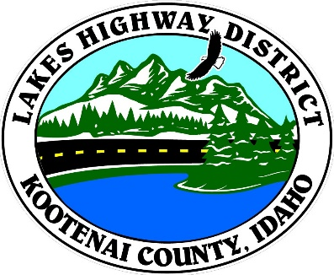

LAKES HIGHWAY DISTRICT
NOTICE OF SPECIAL MEETING

The Chairman of the Board of Commissioners of the Lakes Highway District has called a special meeting to be held on April 21, 2022 at the hour of 12:00 p.m. at 11341 N. Ramsey Road, Hayden, Idaho 83835, for the purpose of:

1. Call Meeting to Order
2. Pledge of Allegiance
3. Approve April 21, 2022 Special Meeting Agenda (Action Item)
4. Public Comment - this section is reserved for citizens wishing to address the Board regarding a District related issue. Comments are limited to two (2) minutes per person. Idaho Law prohibits Board action on items brought under this section.
5. Schedule UPRR Bridge Project Public Hearing (Action Item)

6. Adjourn

BOARD OF COMMISSIONERS
THE LAKES HIGHWAY DISTRICT

Rodney A. Twete, Chairman

Any person needing special accommodations to participate in the above noticed meeting should contact Lakes Highway District two (2) business days prior to the meeting at (208)772-7527.

