Discrimination Complaint Procedure
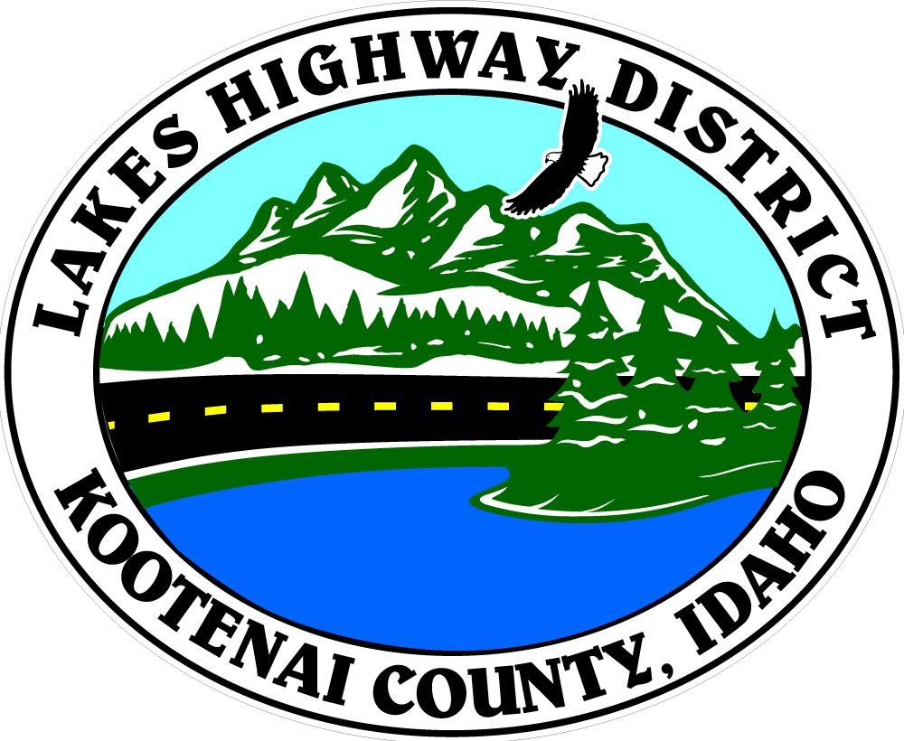

11341 N. Ramsey Road, Hayden, ID 83835
Phone (208)772-7527 Fax (208)772-7411

Any person who believes that he or she, individually, as a member of any specific class, or in connection with any disadvantaged business enterprise, has been subjected to discrimination prohibited by Title VI of the Civil Rights Act of 1964, the American with Disabilities Act of 1990, Section 504 of the Vocational Rehabilitation Act of 1973 and the Civil Rights Restoration Act of 1987, as amended, may file a complaint with Lakes Highway District. A complaint may also be filed by a representative on behalf of such a person. All complaints will be referred to the Lakes Highway District’s Title VI Coordinator for review and action.

In order to have the complaint considered under this procedure, the complainant must file the complaint no later than 180 days after:

a.) The date of alleged act of discrimination; or

b.) Where there has been a continuing course of conduct, the date on which that conduct was discontinued.

In either case, the Lakes Highway District or his/her designee may extend the time for filing or waive the time limit in the interest of justice, specifying in writing the reason for doing so.

Complaints shall be in writing and shall be signed by the complainant and/or the complainant’s representative. Complaints shall set forth as fully as possible the facts and circumstances surrounding the claimed discrimination. In the event that a person makes a verbal complaint of discrimination to an officer or employee of the Lakes Highway District, the person shall be interviewed by the Title VI Coordinator. If necessary, the Title VI Coordinator will assist the person in reducing the complaint to writing and submit the written version of the complaint to the person for signature. The complaint shall then be handled according to the Sponsor’s investigative procedures.

Within ten days, the Title VI Coordinator will acknowledge receipt of the allegation, inform the complainant of action taken or proposed action to process the allegation, and advise the complainant of other avenues of redress available, such as to the Idaho Transportation Department (ITD) and/or the US Department of Transportation (USDOT).

The Lakes Highway District will advise ITD within 10 days of receipt of the allegations. Generally, the following information will be included in every notification to ITD:

a.) Name, address, and phone number of the complainant.

b.) Name(s) and address(s) of alleged discriminating officials(s).

c.) Basis of complaint (i.e., race, color, national origin, or sex)

d.) Date of alleged discriminatory act(s).

e.) Date of complaint received by the Lakes Highway District.

f.) A statement of the complaint.

g.) Other agencies (state, local, or federal) where the complaint has been filed.

h.) An explanation of the actions the Lakes Highway District has taken or proposed to resolve the issue raised in the complaint.

Within 60 days, the Title VI Coordinator will conduct an investigation of the allegation and based on the information obtained, will render a recommendation for action in a report of findings to the Lakes Highway District authorized representative. The complaint should be resolved by informal means whenever possible. Such informal attempts and their results will be summarized in the report of findings.

Within 90 days of receipt of the complaint, the Lakes Highway District’s authorized representative will notify the complainant in writing of the final decision reached, including the proposed disposition of the matter. The notification will advise the complainant of his/her appeal rights with ITD, or USDOT, if they are dissatisfied with the final decision rendered by the Lakes Highway District. The Title VI Coordinator will also provide ITD with a copy of this decision and summary of findings upon completion of the investigation.

Contacts for the different Title VI administrative jurisdictions are as follows:

Lakes Highway District
Eric W. Shanley, Director of Highways
11341 N. Ramsey Road
Hayden, Idaho 83835
208-772-7527
eric@lakeshighwaydistrict.com

Idaho Transportation Department
Equal Employment Opportunity Office – External Programs
Ken Angell, EEO Manager
PO Box 7129
Boise, Idaho 83707-1129
208-334-8884
ken.angell@itd.idaho.gov

Federal Highway Administration
Idaho Division Office
Peter Hartman, Division Administrator
3050 Lakeharbor Lane, Ste 126
Boise, Idaho 83703
208-334-9180

