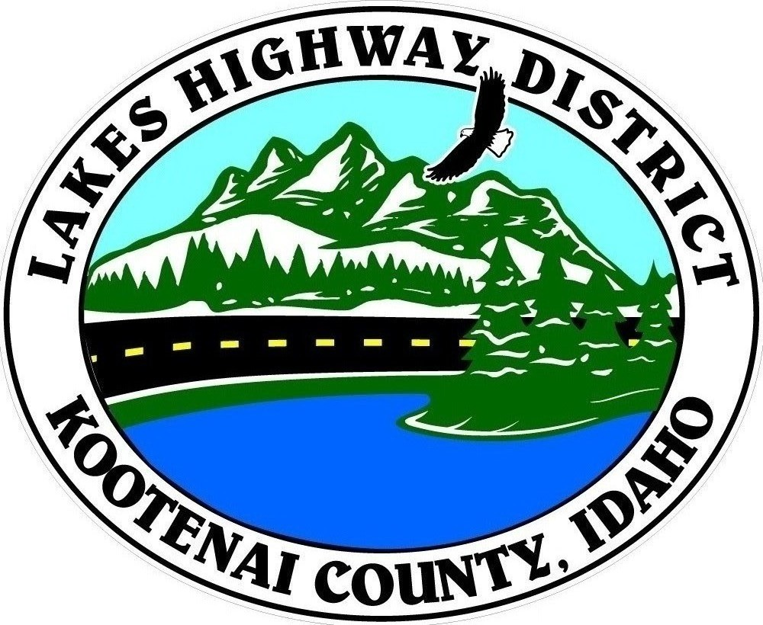
LAKES HIGHWAY DISTRICT
Chairman, Rodney A. Twete, Commissioner District 1
Vice Chairman, Weston E. “Monty” Montgomery, Commissioner District 2
Diane J. Fountain, Commissioner District 3

BOARD MEETING AGENDA

February 21, 2022 - 5:30 p.m.
11341 N. Ramsey Road
Hayden, Idaho 83835

1. Call Meeting to Order
2. Pledge of Allegiance
3. Approve February 21, 2022 Meeting Agenda (Action Item)
4. Approve February 7, 2022 Regular Meeting Minutes (Action Item)
5. Administrative Matters
a. Approve Financial Reports – (Action Item)
6. Public Comment – this section is reserved for citizens wishing to address the Board regarding District related issue. Comments are limited to two (2) minutes per person. Idaho Law prohibits Board action on items brought under this section.
7. Old Business
a.
8. Current Business
a. Bunco Ranch Plat Preliminary Review (Action Item)
b. Tessendorf Plat Review (Action Item)
c. Waymaker Ridge Plat Review (Action Item)
d. Upper Wildcat Plat Review (Action Item)
e. Wildcat South Plat Review (Action Item)
f. Rucinsky Acres Plat Review (Action Item)
g. Johnson Subdivision Exemption Review (Action Item)
h. FY2023 Budget Hearing Notification (Action Item)
i. Consider Award of Chip Quote (Action Item)
j. Consider Award of Construction Projects (Action Item)
k. Surplus Equipment Transfer to East Side Highway District (Action Item)

9. Executive Session
a.
10. Upcoming Meetings
a. Lakes Highway District Meeting – March 7, 2022 – 5:30 p.m.
11. Commissioner Comments
12. ADJOURN

Any person needing special accommodations to participate in the above noticed meeting should contact Lakes Highway District five (5) days prior to the meeting at (208)772-7527 or 11341 N. Ramsey Road, Hayden, Idaho 83835.

